**ECS**

**ECS:** Elastic Container Service

**ECR:** Elastic Container Registry

**EKS:** Elastic Kubernetes Service

**CMS:** Container Management Service

**Docker:** Software Development Platform

**Kubernetes:** Container Management Platform

Amazon **Elastic Container Service** (ECS) is a highly scalable, high performance container management service that supports Docker containers and allows you to easily run applications on a managed cluster of Amazons EC2 instances.

Amazon ECS eliminates the need for you to install, operate, and scale your own cluster management infrastructure. With simple API calls, you can launch and stop container-enabled applications, query the complete state of your cluster, and access many familiar features like security groups, Elastic Load Balancing, EBS volumes and IAM roles.

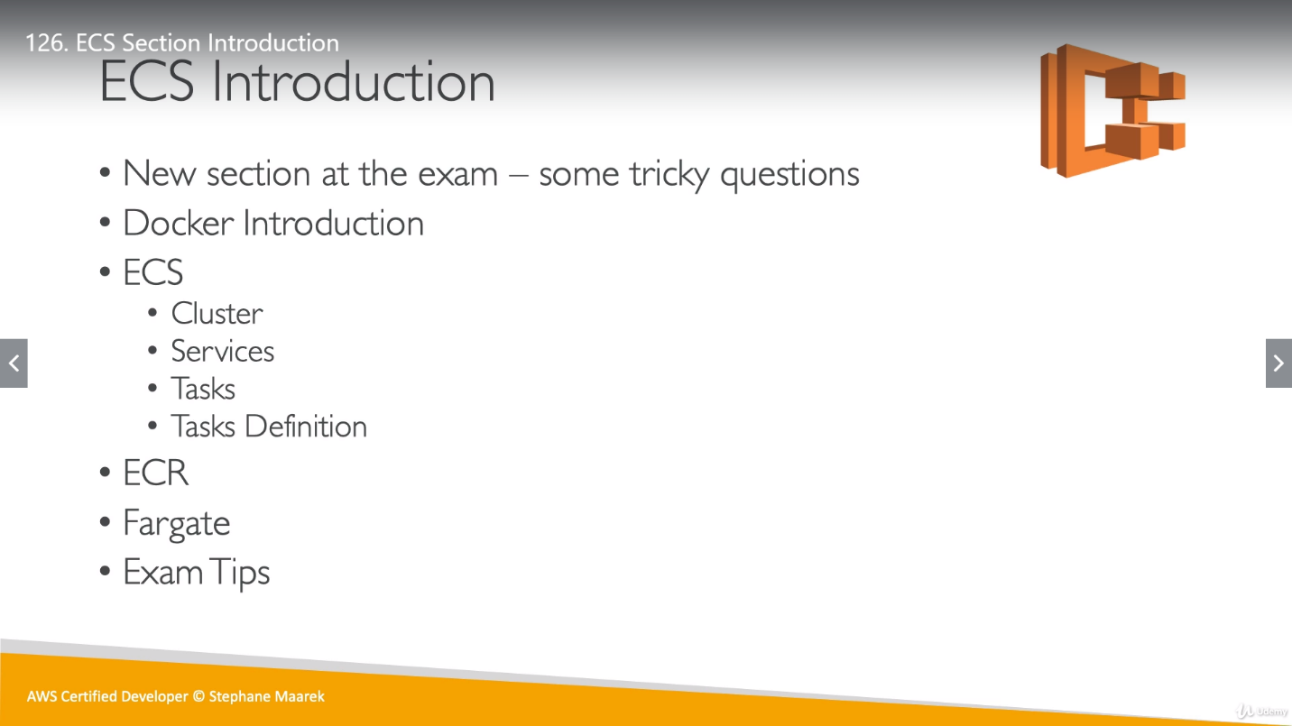

**CMS**: Container Management is the process of organizing, adding or replacing large numbers of software containers. Container management uses software to automatically create, deploy and scale containers. This gives rise to the need for container orchestration—a more specialized tool that automates the deployment, management, scaling, networking, and availability of container-based applications. For example, Kubernetes manages app health, replication, load balancing, and hardware resource allocation for you.

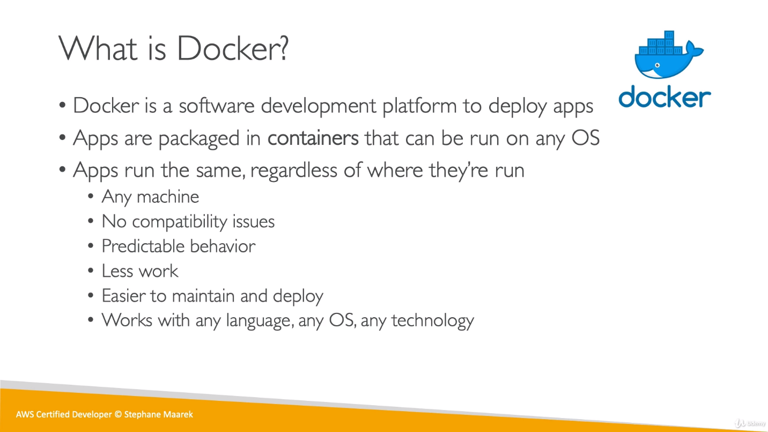

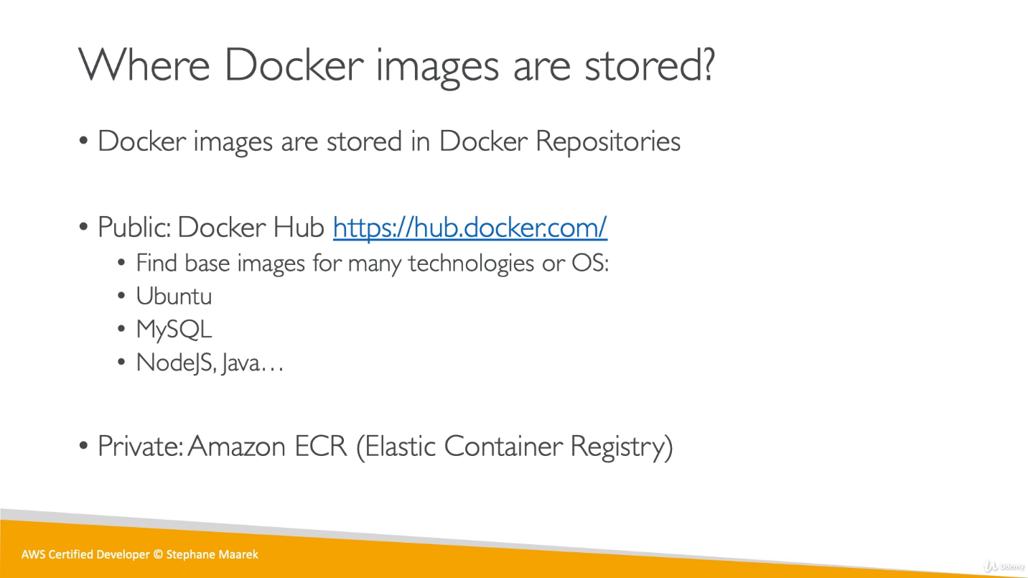

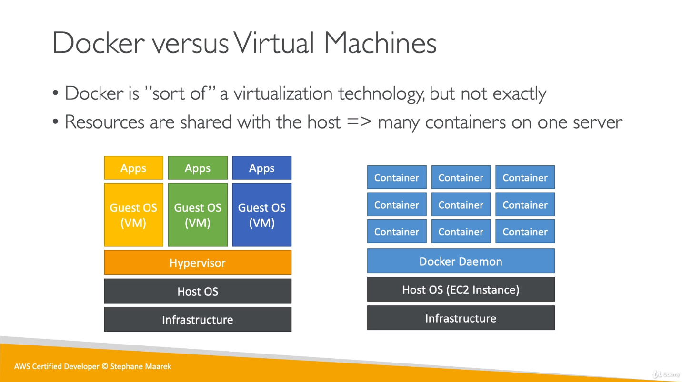

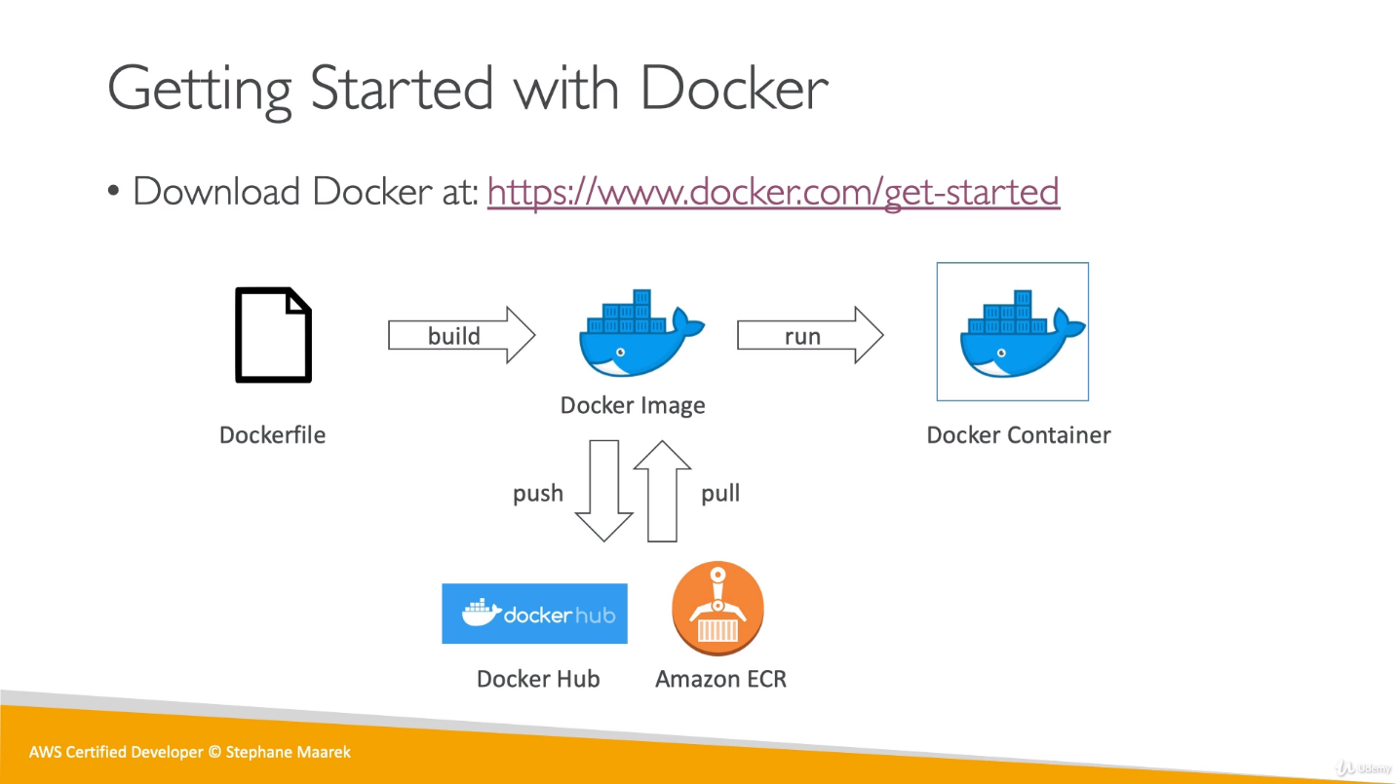

A Dockerfile is a recipe for creating Docker images. A Docker image gets built by running a Docker command (which uses that Dockerfile). A Docker container is a running instance of a Docker image.

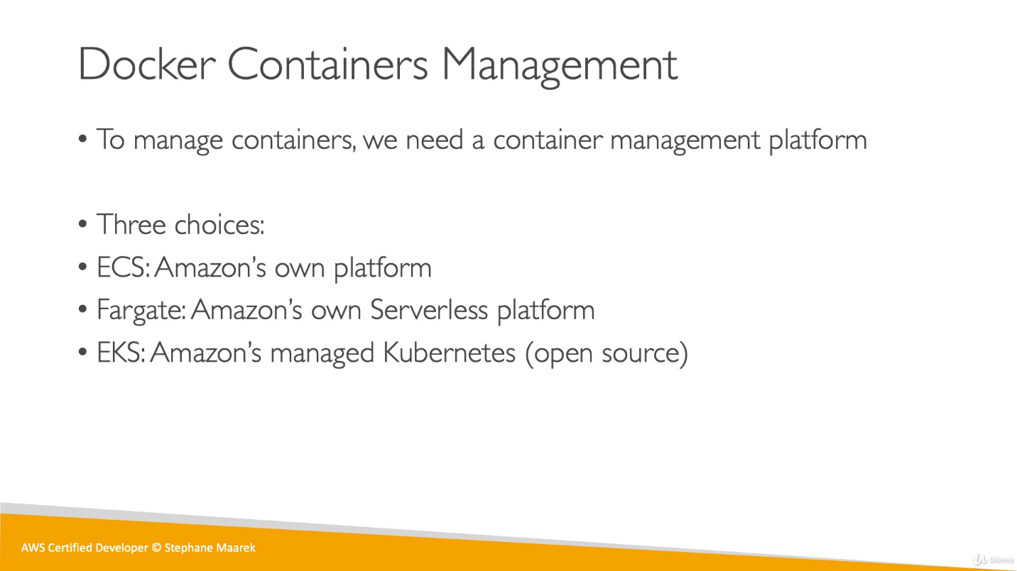

We have 3 choices to use Container Management platform in AWS. ECS, Fargate and EKS.

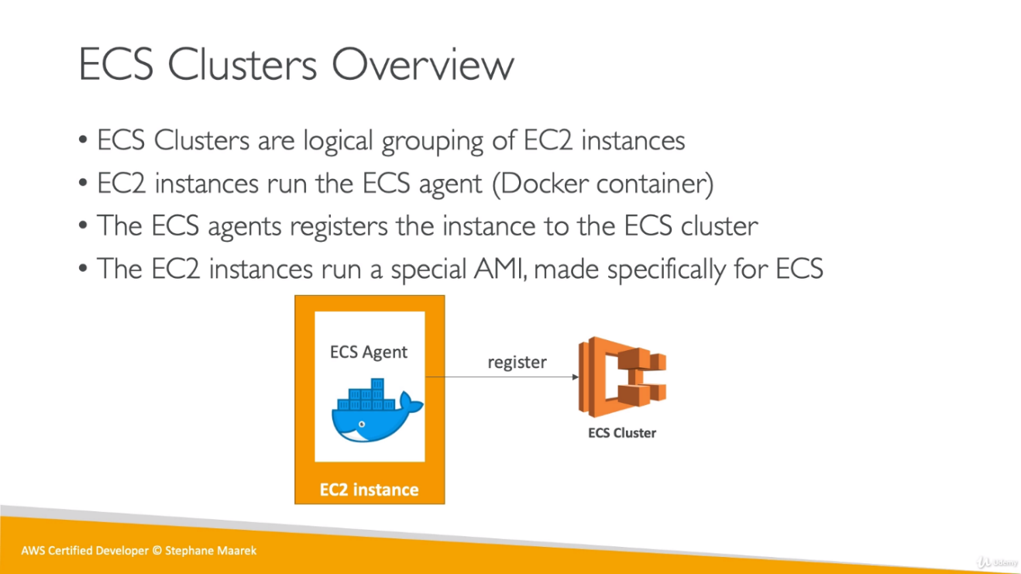

**ECS Agent:** AWS software that allows EC2 container instances to connect to our clusters.

Once ECS agent connects ECS cluster and EC2 instances, It can be used for the services that the instances having.

**Lab:**

Create an ECS cluster (using predefine AMI from AWS where docker is already been installed and create IAM role for it named as **ecsInstanceRole**) -> create ECS Task Definition -> create a service (at cluster level)

**ECS Cluster:**

Once we create ECS cluster, it used a predefined EC2 AMI which already has Docker installed within it. So, after creating an ECS cluster we can see a new instance entry in EC2 instance (which has an IAM role attached to it, this role is having [ecsInstanceRole](https://console.aws.amazon.com/iam/home?region=ap-south-1#/roles/ecsInstanceRole) policy attached to it) for ECS. ECS has also created Launch Configuration (under Auto Scaling Group) for us.

Once we ssh into ECS we can use below command:

cat /etc/ecs/ecs.config

It will give us cluster related information.

docker ps

It will show us docker process running currently on this cluster.

docker logs container_id

It will show complete logs, (what had happened on this container till now).

So, till now we have created an ECS cluster (Which is actually an EC2 instance or no of EC2 instances, having a predefined AMI to have already installed docker container)

**ECS Task Definitions:**

This is the blueprint describing which Docker containers to run and represent our application.

A task definition is required to run Docker containers (Httpd in below example) in Amazon ECS. Some of the parameters we can specify in a task definition include:

* The Docker image to use with each container in your task.
* How much CPU and memory to use with each task or each container within a task.
* Port Binding between Host and container

Task Definition don’t get created at ECS cluster level, we add ECS cluster while creating Task definition.

We have to assign memory and RAM at the time of task definition creation so once it will be attached to ECS cluster, it will use this much memory from ECS.

**Add container:** It means which container we want to add to this task like httpd

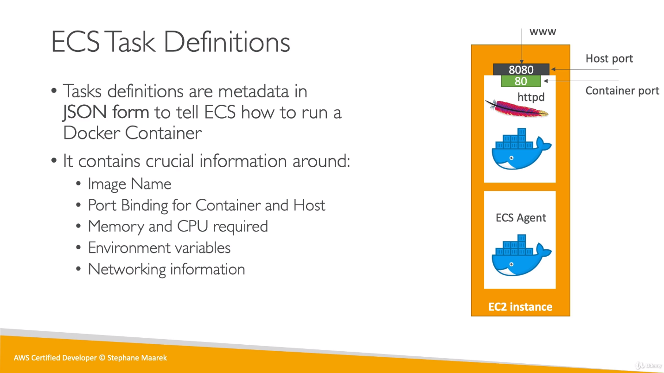

**ECS Service:**

Defines the minimum and maximum Tasks from one Task Definition run at any given time.

It also defines autoscaling and load balancing.

Service gets created at ECS cluster level. (not like task definition). We choose service type as replica that mean if we choose 5 replicas, which runs 5 tasks. Other option is Daemon, where no of tasks are automatic. Daemon is used for monitoring purpose.

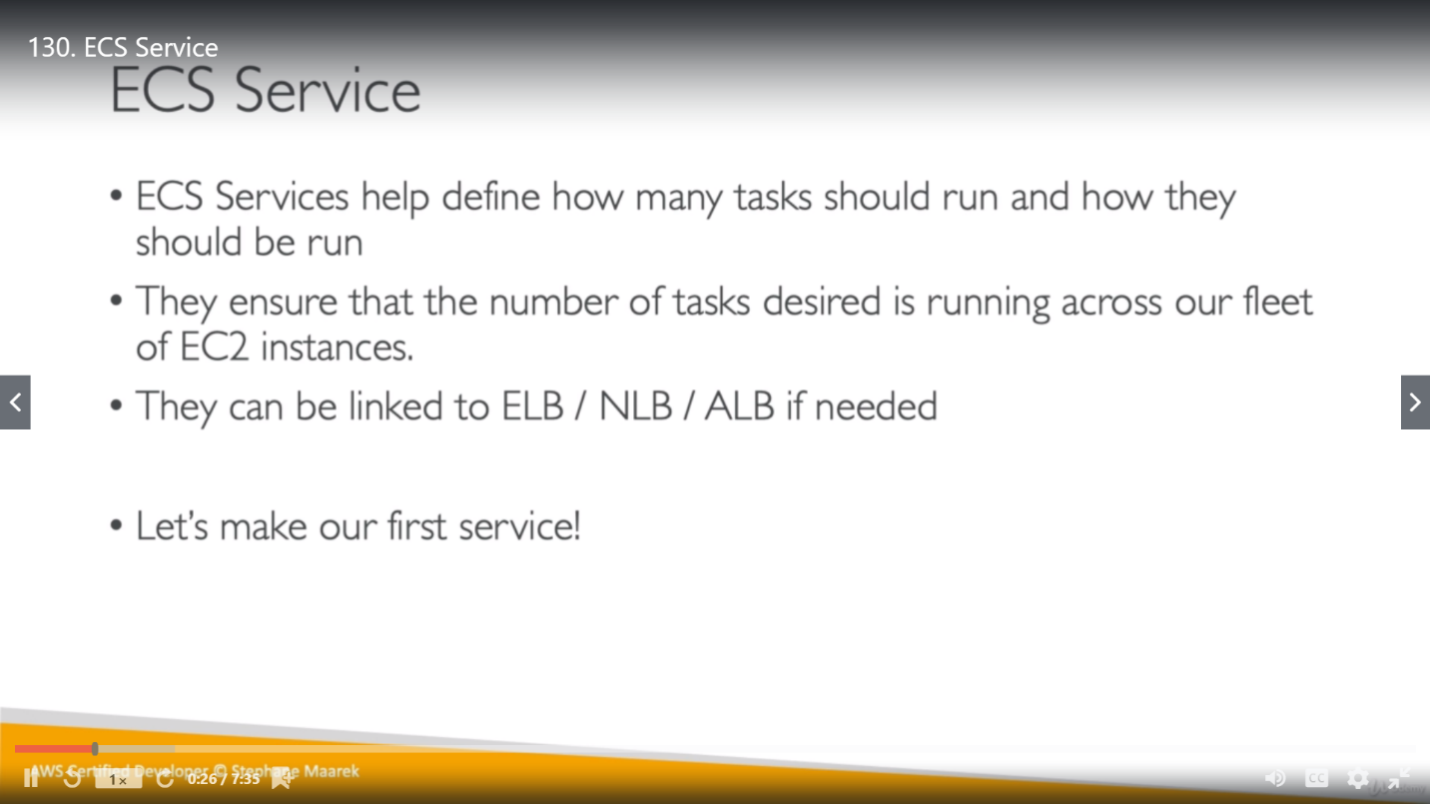

If we scale up our service with another task and update our service (number of tasks as 2), it will be updated but won’t create a new Task.

For one Task Definition, we can have one task per ECS instance because if we try to launch a second task, it will try to connect to same port (as 8080 in our case) but it is already used by our instance (for httpd mapping). We can resolve this in 2 ways:

1. **Without ALB:**

Increase desired capacity as 2 in Autoscaling group for the EC2 instance (instance for this ECS cluster) or click on ECS instances and we will have an option as scale ECS instances. (both will work for each other if one updated another will update automatically).

Now we can see 2 ECS instances and 2 Tasks.

Till now, we have a clear picture, there are 2 instances in ECS cluster which have single Task Definition and service with number of tasks as 2.

So, we can hit these instance’s public IP with port 8080 and both will work.

We are not doing Load Balancing till now.

1. **With ALB:**

**ECS Service using ALB**

We can have multiple httpd server under multiple EC2 instances and they can have any random port number. Along with ALB, ECS uses **“Dynamic Port Forwarding”** concept for this solution.

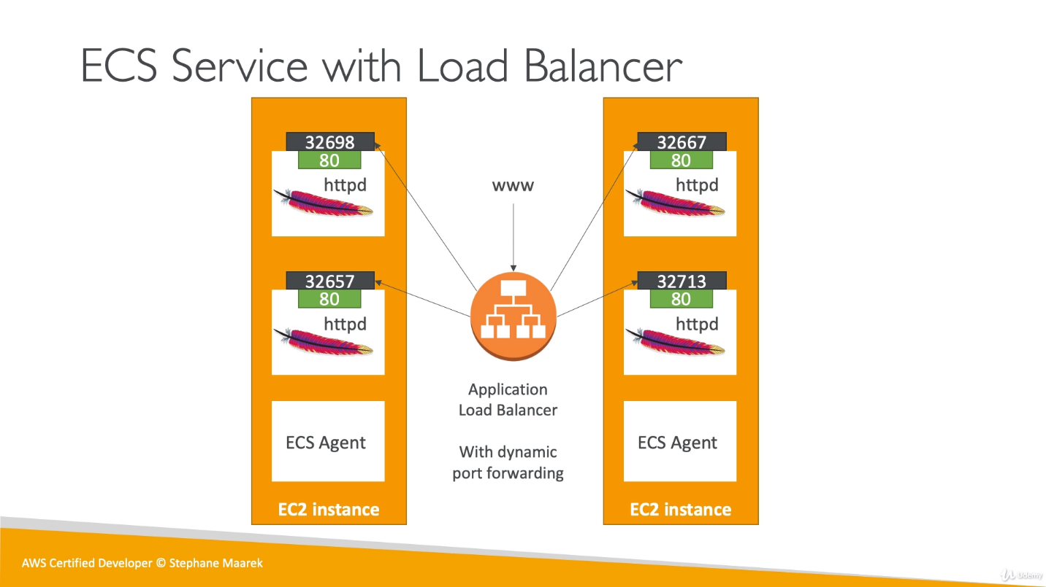

**Modify/ create Task definition for ALB:** For this scenario we don’t define host port (EC2 port to access the application, as earlier 8080), we will have only container port (80 for httpd) in Task Definition.

**Modify/create Service for ALB:** Once we updated Task Definition, change Task definition revision with latest generated version in service and now we can define as many tasks as we want (ex- 4) in this service (Because we have removed Host port from Task definition).

Once this service got updated, we can see 4 tasks has been created now in Tasks tab. Now if we check **“docker ps”** command in SSH EC2 shell, we could see random ports have been assigned to Httpd.

We had already Increased 1 instance earlier from ASG, and now we define 4 tasks so each instance will be having 2-2 tasks, this can be seen in ECS instances.

* Till now we haven’t added any Load Balancer and we can’t add any Load Balancer for already created services (with same Task Definition). So, we have to create a new service but before that we have to create ALB.

Create a new ALB with new security group (can be without TG) as we create usually and then need to add in new service.

We have to modify our security group that was created for ECS EC2 instances by changing its inbound traffic as “**Allow all traffic from ALB’s security group on all ports**”

Only ALB have Dynamic port mapping feature not the classic load balancer.

So now we have ALB which is communicating with ECS EC2 instances on all ports. So now we are good to create a new service with this ALB and modified “Task definition”.

In this new service, choose container to load balance, as 80:HTTP that mean, traffic coming on port 80 will go to all HTTP of ECS instances.

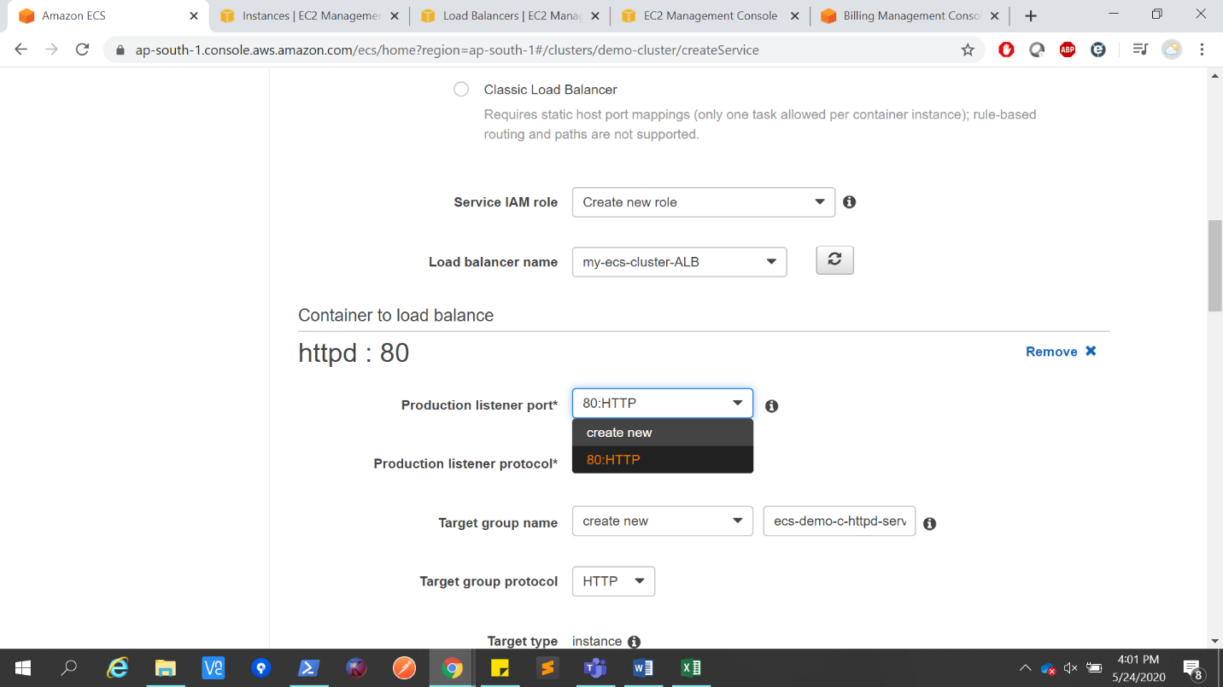

If we want to delete any service, first we have to update number of tasks as 0 and then only it will allow to delete it.

**ECR**

ECR: Elastic Container Registry

It’s an aws private repository to store docker images. Its managed by IAM using required policies. AWS CLI v1 and v2 versions have different commands to authenticate against ECR.

v1: Executing the output of AWS ECR get-login command.

**$(aws ecr get-login --no-include-email --region eu-west-1)**

v2: Piping the output of get-login password command into the docker login command.

**aws ecr get-login-password --region eu-west-1 | docker login --username AWS --password-stdin 12345.dkr.ecr.eu-west-1 | .amazonaws.com**

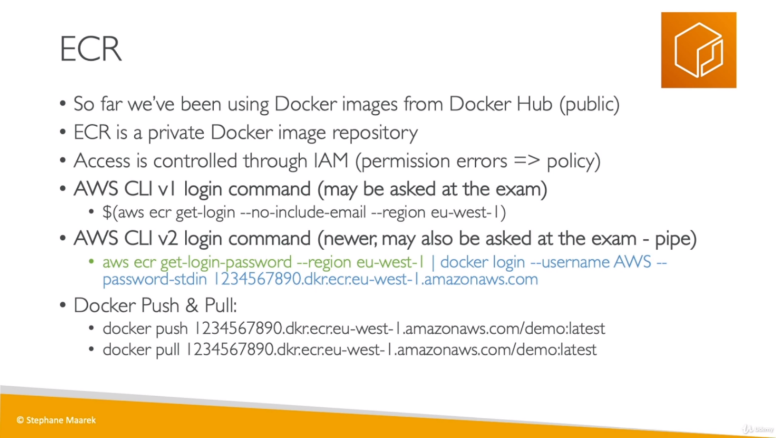

**Fargate**

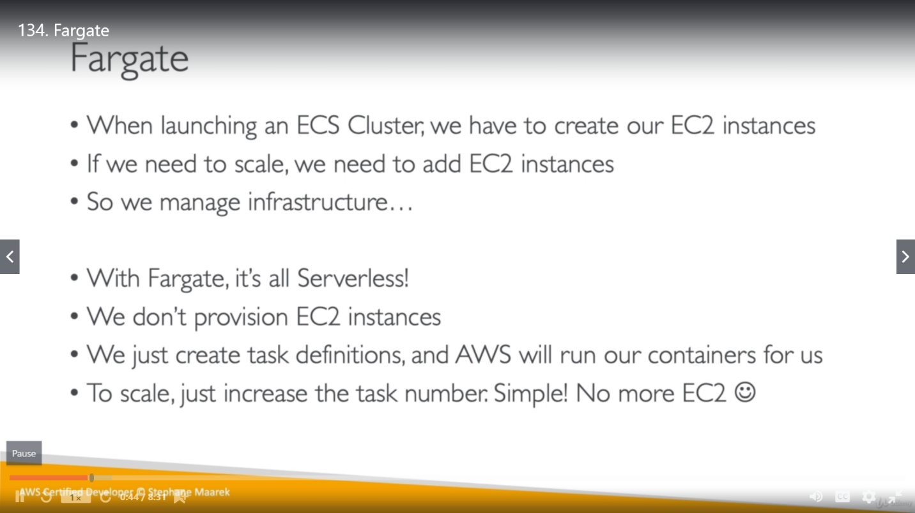

Now, in fargate cluster, we don’t need of EC2 instances as its serverless. Steps are quite easy compare to ECS.

We created a new cluster for fargate and then created a Task Definition and services as well. There is no port mapping as we are using awsvpc or Bridge vpc.

So, it will create no of Tasks based on the “number of tasks” field in service as earlier.

**ECS IAM**

EC2 Instances (created under ECS cluster) needs different roles for different tasks as it might pull a docker image from ECS, send logs to CloudWatch but most important it will have at least a role **ecsInstanceRole,** which will be used by ECS agent to connect EC2 instances to the cluster.

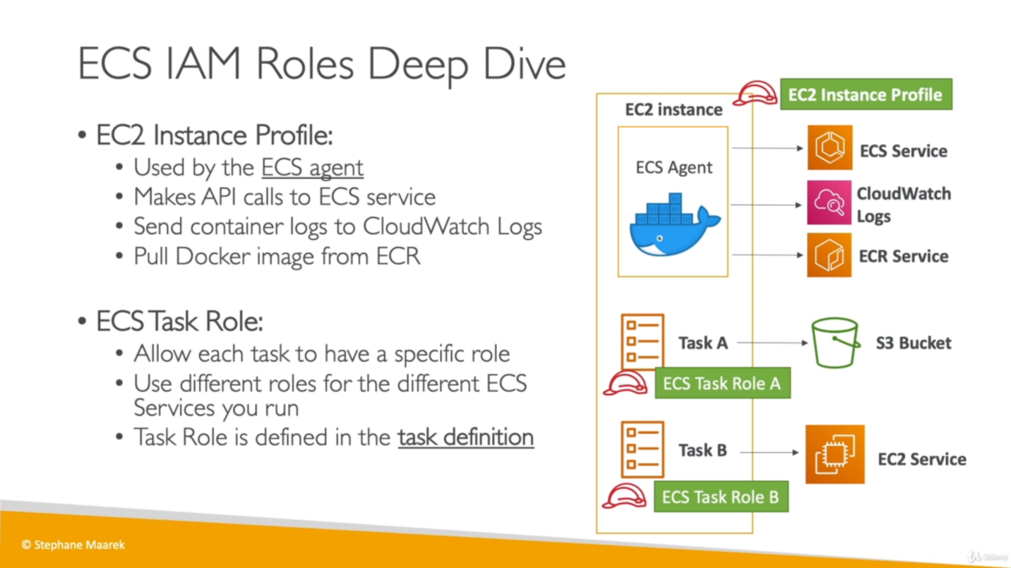

ECS Task roles are different and required based on cluster functioning. We have an option named “Task Definition” under Amazon ECS to see these roles.

Till now basically 4 IAM roles have been created and those are:

**ecsInstanaceRole:** It get attached to EC2 instances. If we see policy attached to it, we can see it allows EC2 connects to ECS service, we can pull images from ECR and it allows EC2 instances to logs in CloudWatch using ECS service. This is not a task role.

**elsServiceRole:** It is attached to ECS service and it allows ECS to perform action on our behalf. So, once we create a new task, it will allow these tasks to be registered with the Elastic Load Balancer So when new task got created, they can be automatically got reserved for ALB.

**ecsTaskExecutionRole:** It’s a task role. This role is assigned to ECS task and services. It allows get images from ECS and send logs to CloudWatch. For Each task we create we need to create a separate ecsTaskExecutionRole.

**AWSServiceRoleForECS:** It allows ECS service to perform some actions on our behalf and these actions allows a lot of things like create Network interfaces, Register load balancer, route-53 and so on.

**ECS Task Placement:**

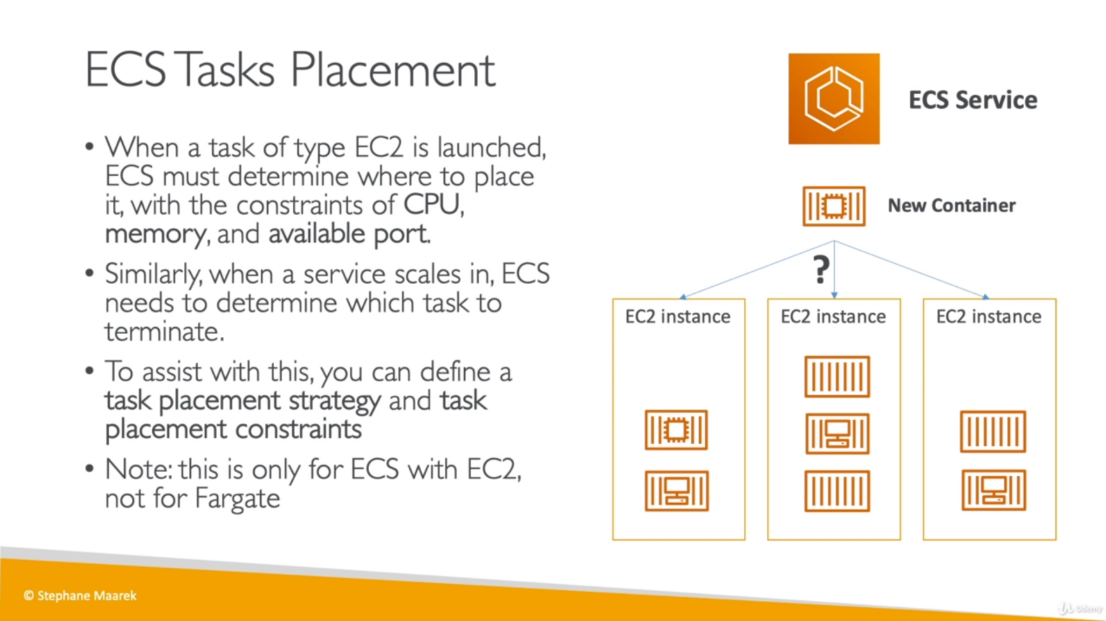

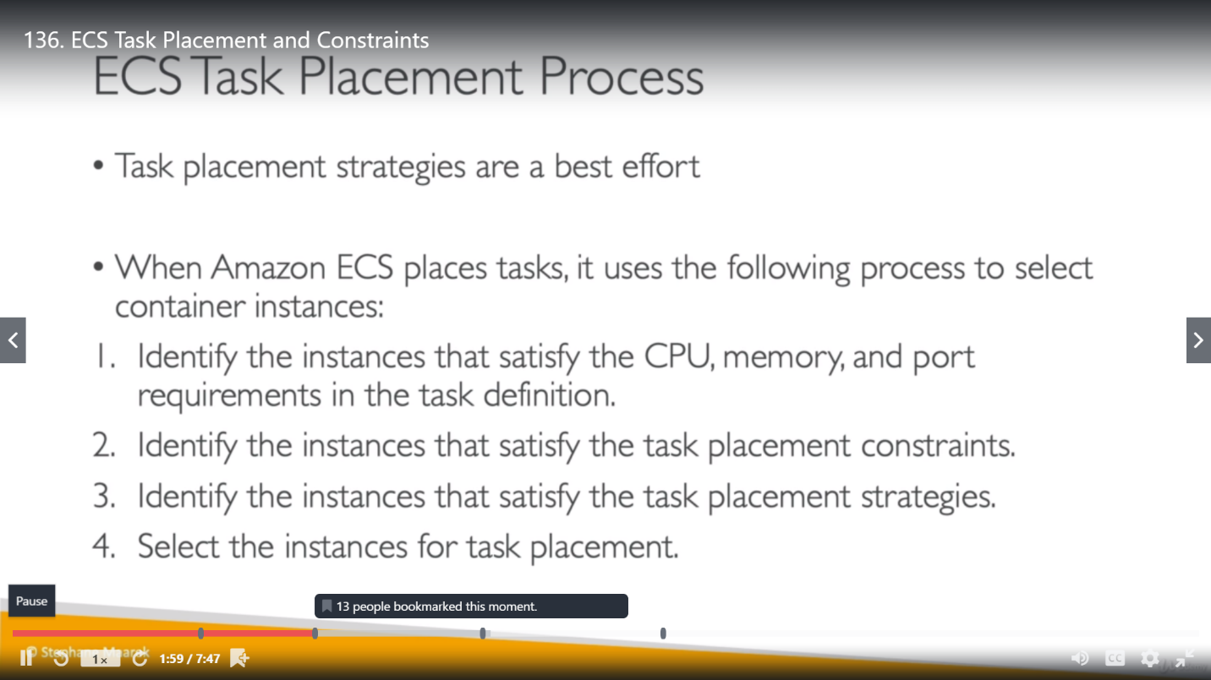

1. **Binpack:** Place as many containers as possible on a single instance and once it filled then start with another EC2 instance.

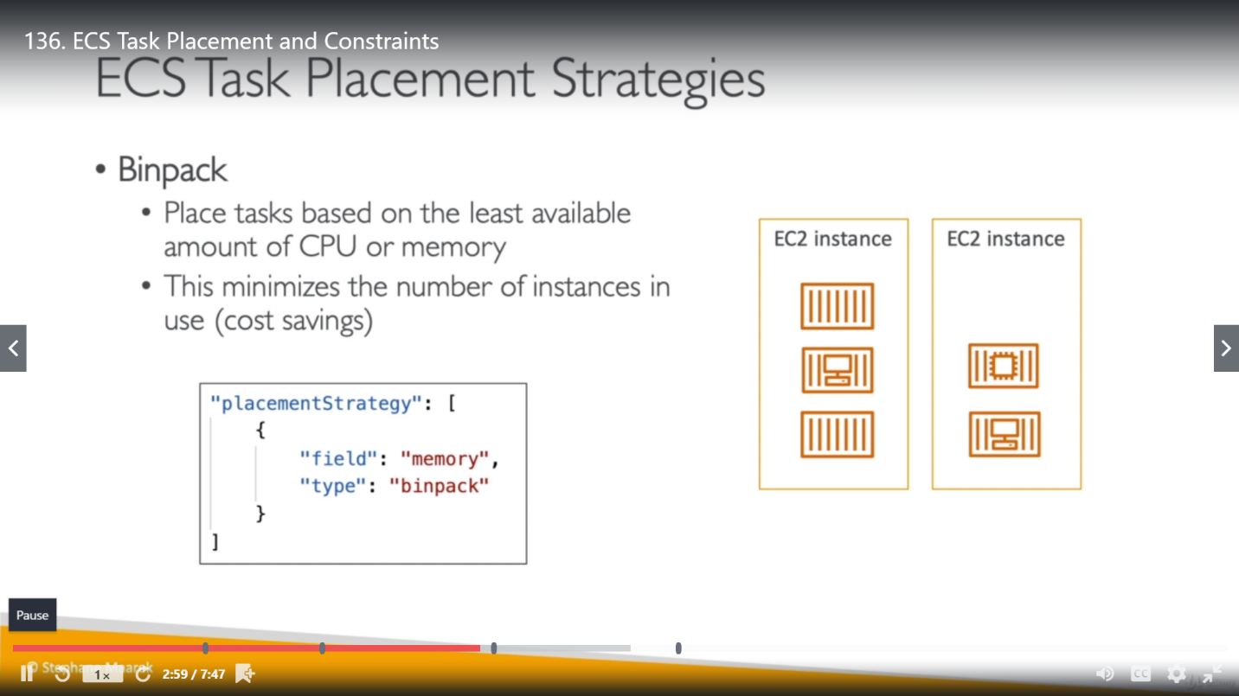

1. **Random:** It places the task randomly.

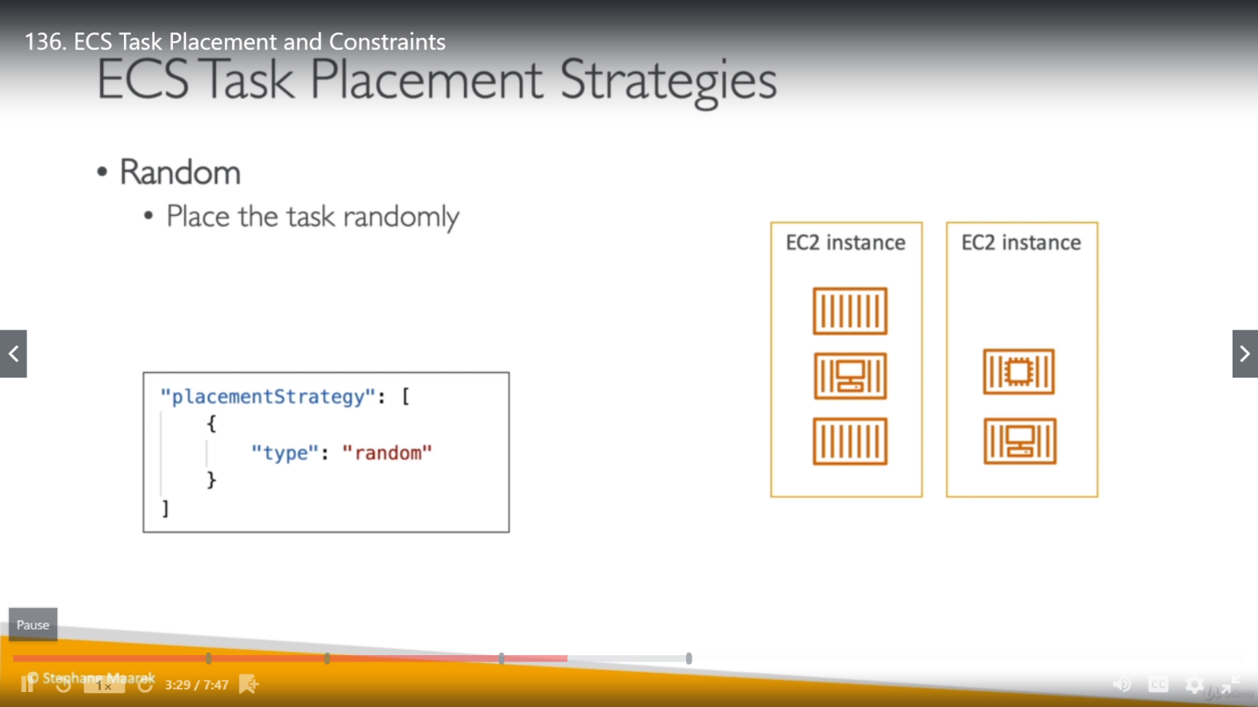

1. **Spread:** Task will be spread evenly across the AZ.

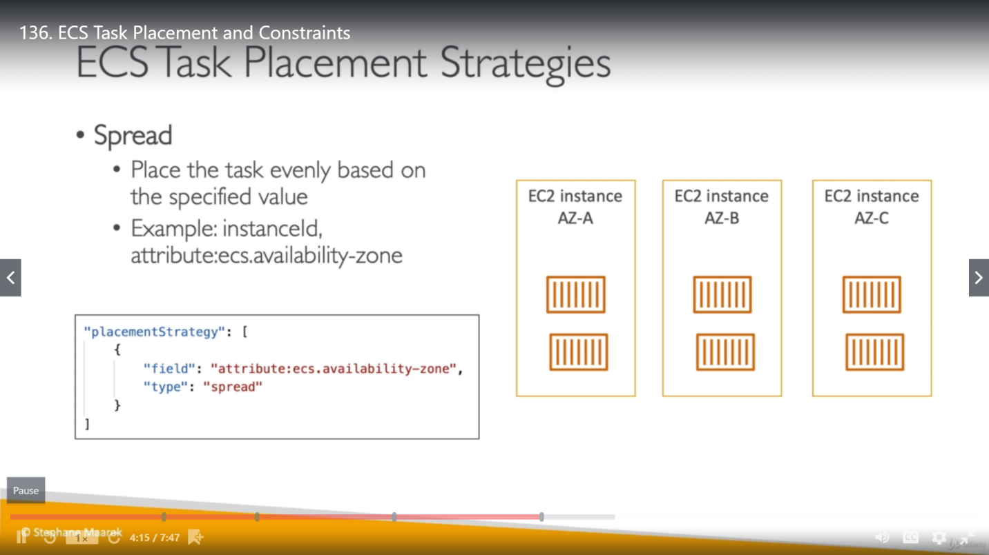

These strategies can be mixed together.

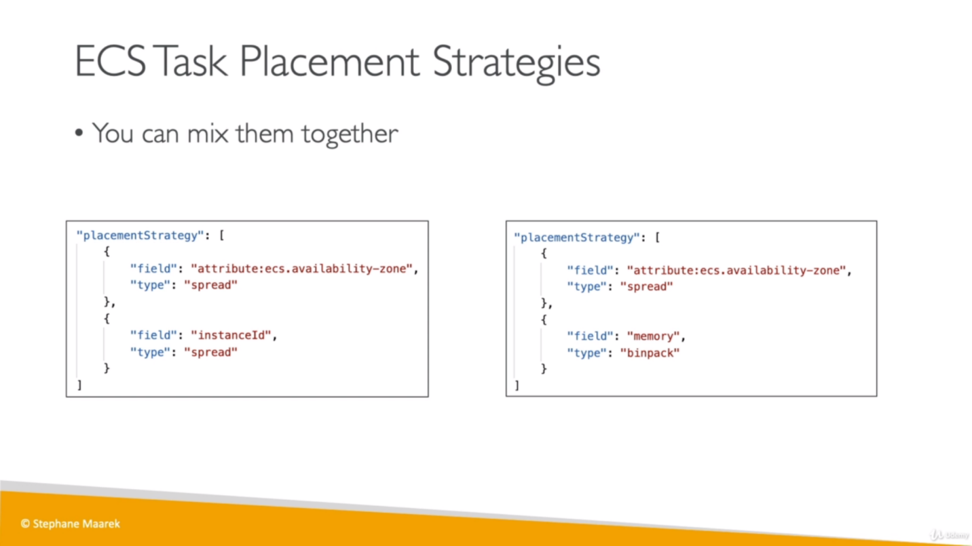

**ECS Task Placement Constraints:**

1. **distinctInstance**
2. **memberOf**

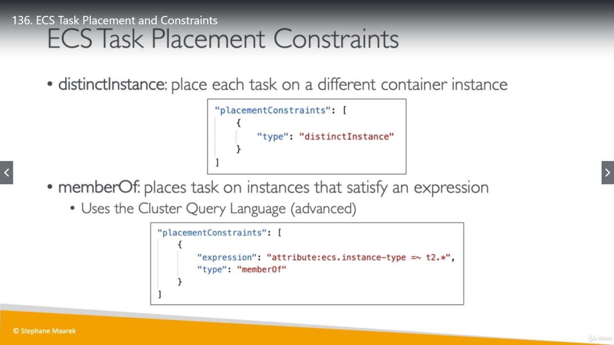

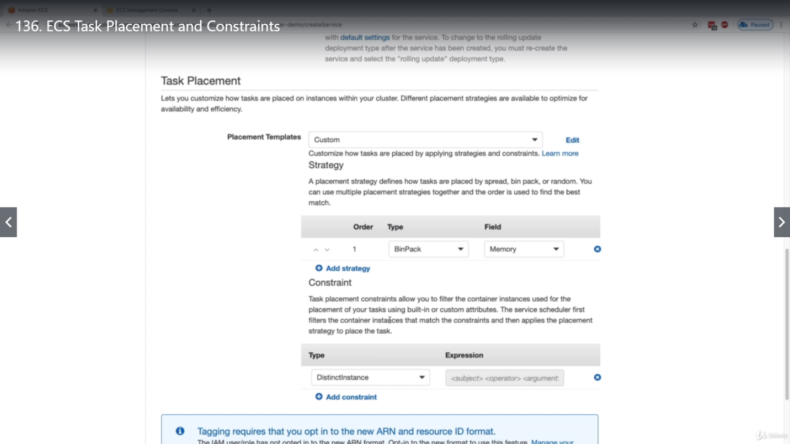 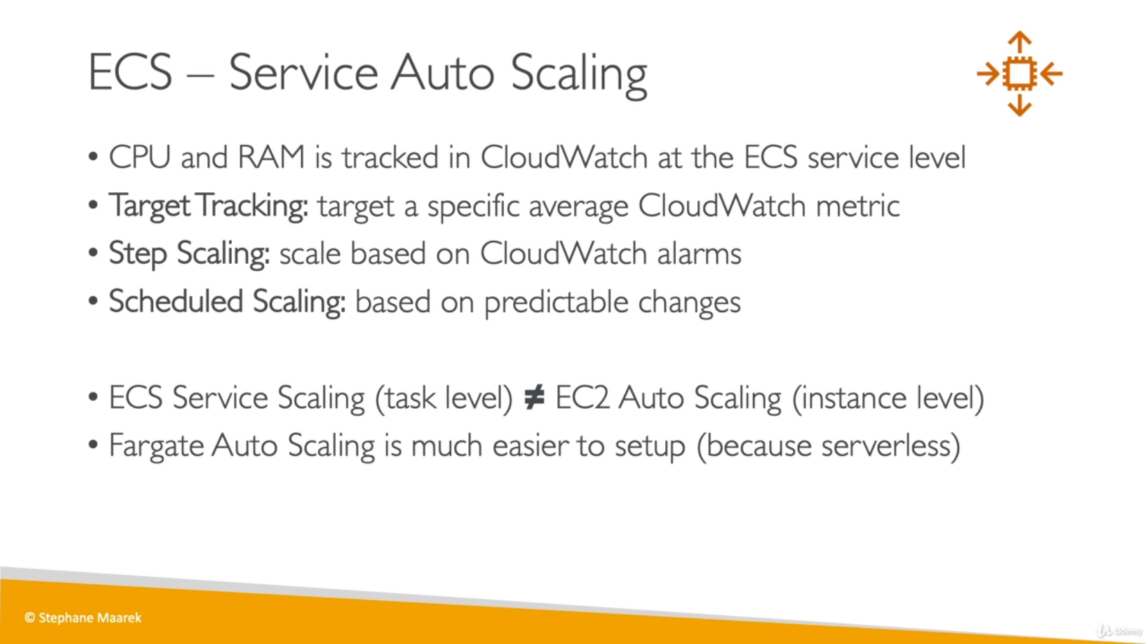

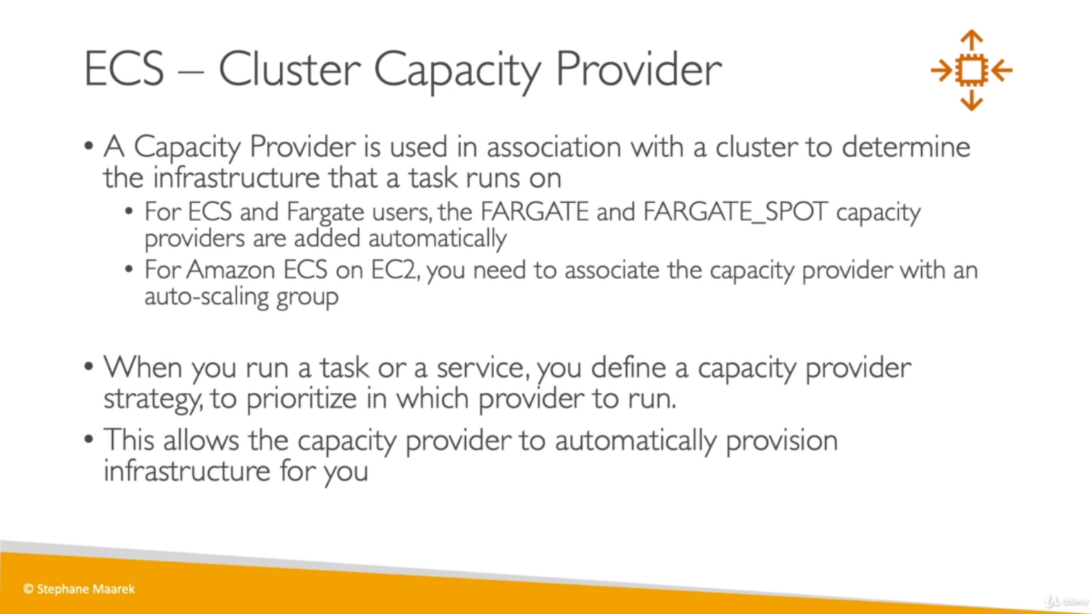 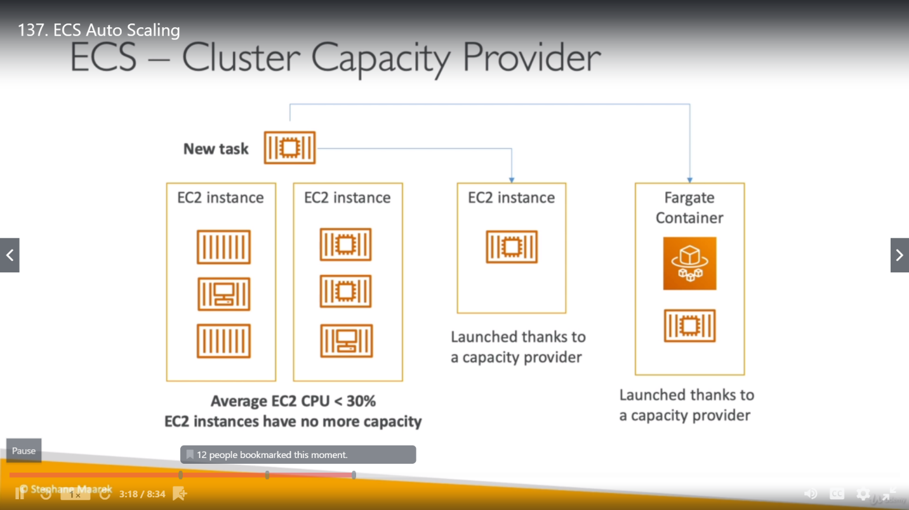 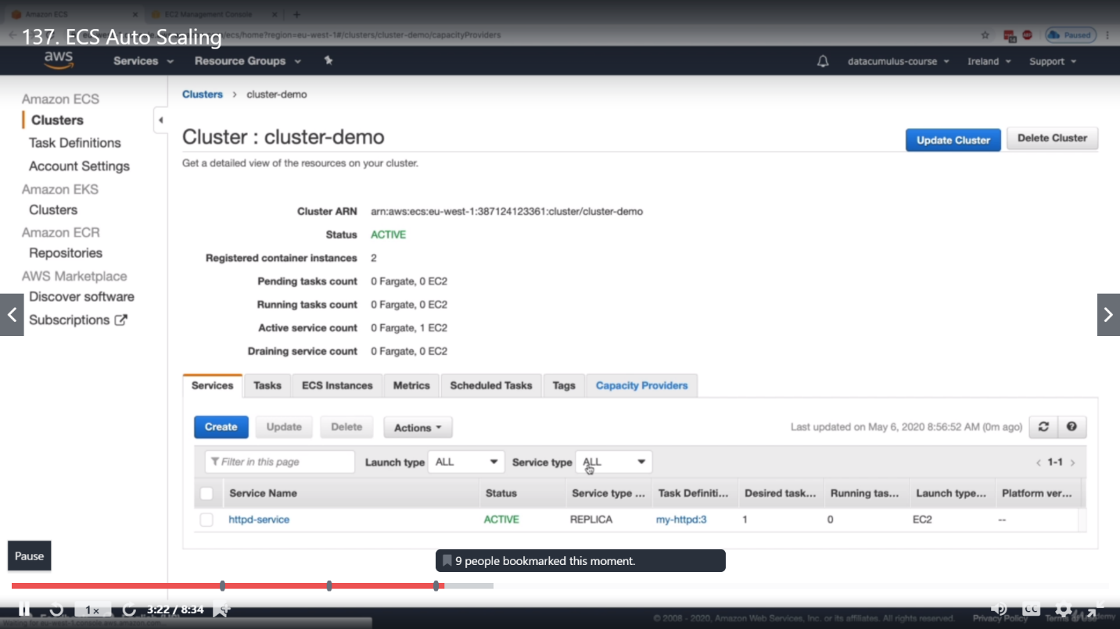 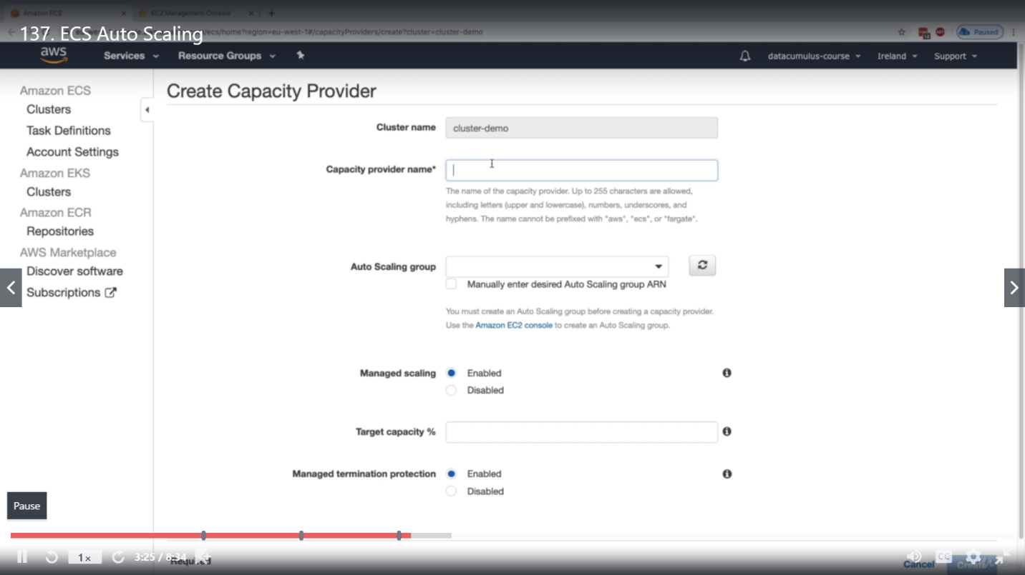

Revise:

